

DATA ANALYSIS

CASE STUDY: LOS ANGELES LAKERS

DATA ANALYST/RESEARCHER/CODER: OSINOWO ABDULAZEEZ

## Tools and languages used:

libraries like Pandas for data cleaning,data analysis

Matplotlib for Data visualization

## Data Source/Data mining :

Source - Data was scraped from [www.basketballreference.com](www.basketballreference.com%20) using Beautiful soup and converted into multiple csv files ,the multiple csv files were read together using pandas

## Data Cleaning:

* checked for duplicates
* checked for null values
* Many columns contained NaN values
* Rows with NaN values were dropped
* Columns with some NaN values were filled

## **NBA TEAMS/LAKERS ANALYSIS**

Research questions:

1. Check top point guard, shooting guard,centers and power forward in the league
2. To find the most consistent player in the lakers team over the years
3. To find the most consistent player over the years
4. To find the most improved player in the squad over the years
5. To find a new point guard at least 5 good trade options
6. To find the contributions of the players to team success
7. Check the defensive players of the year.

## ANALYSIS AND FINDINGS

Best point guards over the years based on maximum points in a season ; Figure 1.0 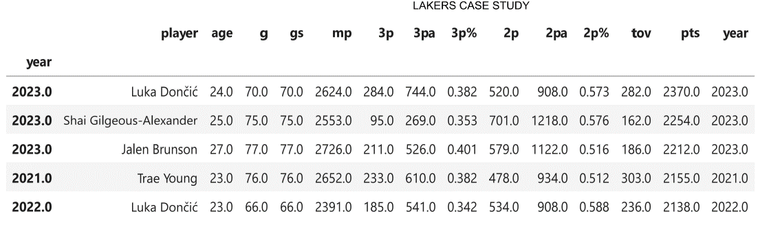

Based on stats the most reliable and consistent PG over the years :

* Luka doncic
* Shai-Gilgeous
* De’Aron fox
* Trae young
* Steph curry
* Jalen Brunson
* Dejounte murray
* Fred vanfleet
* Ja morant
* Donovan mitchelle
* Kyrie irving.

## YEAR 2023

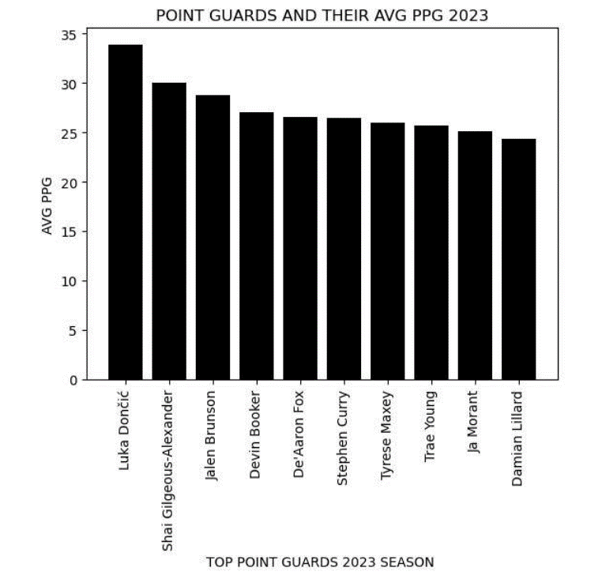

Figure 3.0: Bar chart showing top PG 2023 season

## YEAR 2022

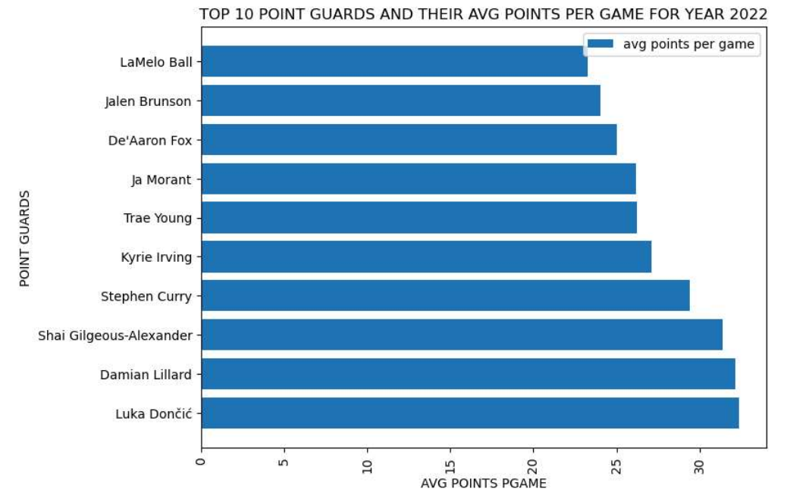

Figure 3.0 : Bar chart showing the top 10 point gaurds in year 2022 based on avg points per game

Over the past 4 years the lakers the highest avg ppg by a point guard was by Lebron james in 2020 when we won the championship , he averaged 25pts per game and he played 45 games as a point guard, followed by Dlo who came in 2022 and provided more stability he averaged 18pts pgame last season.

## LAKERS PGS VS OTHER PGS

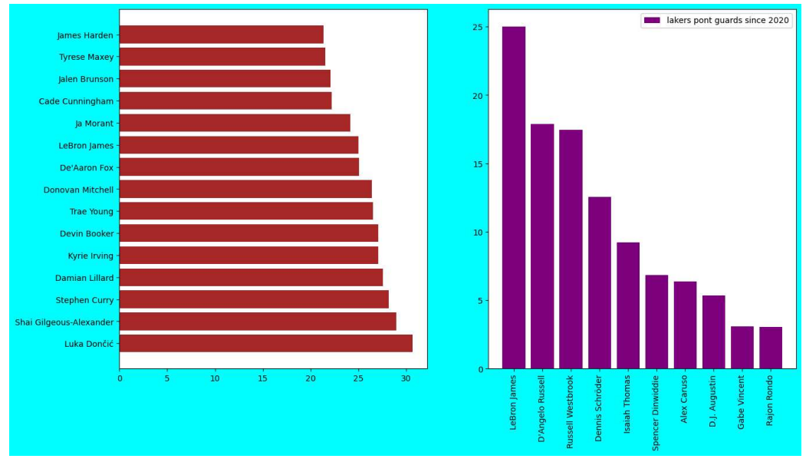

The best options for the lakers are listed above but the trade depends on the contracts these players are on , most of them are super max contracts.

## LAKERS ROASTER CONTRIBUTION

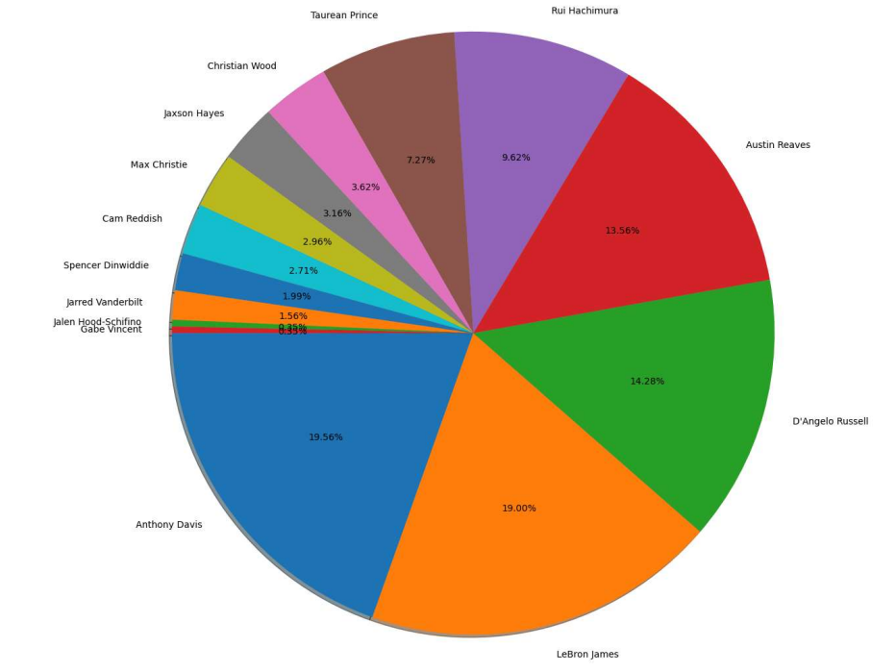

Anthony davis has been consistent this season, he stayed healthy and committed , he’s basically the engine of the team , the offense runs through him and he’s the engine of the defense.

Some players like Cam reddish , Vanderbilt shows prospective buh they were unable to showcase their potential due to injury ; they are crucial to the team and should be kept and incorporated into the runnings.

Other players liked Tauren Prince,Spencer Dinwiddle and probably Rui can be traded for better role players to assist the team.

This is lebron’s 21st season and e still contributes a lot to the team offense and defense , he keeps showing up at 39.